Name: ……………………………………………….. ( ) Class: ……… Date: …………………..

|  |  |  |
| --- | --- | --- |
| **1.1** | **Data Management** | **Lookup, Date and Text Functions** |

**Lookup functions**

|  |  |  |
| --- | --- | --- |
| **Function** | **Syntax** | **Description** |
| HLOOKUP() | =HLOOKUP(lookup_value, table_range, row_index_num, range_lookup)   * range_lookup is an optional argument and can be either TRUE or FALSE | Looks for lookup_value in the first row of table_range and returns the value in row row_index_num of the matching column.  If range_lookup is TRUE, the function performs an approximate match.  If range_lookup is FALSE, the function performs an exact match.  If range_lookup is left out, the function performs an approximate match. |
| VLOOKUP() | =VLOOKUP(lookup_value, table_range, col_index_num, range_lookup)   * range_lookup is an optional argument and can be either TRUE or FALSE | Looks for lookup_value in the first column of table_range and returns the value in column col_index_num of the matching row.  If range_lookup is TRUE, the function performs an approximate match. If range_lookup is FALSE, the function performs an exact match.  If range_lookup is left out, the function performs an approximate match. |

**Date function**

|  |  |  |
| --- | --- | --- |
| **Function** | **Syntax** | **Description** |
| TODAY() | =TODAY() | Returns the current date |

1. The spreadsheet below contains 2 tables. One table shows the elective taken by each student and the other table shows the cost of the different electives.

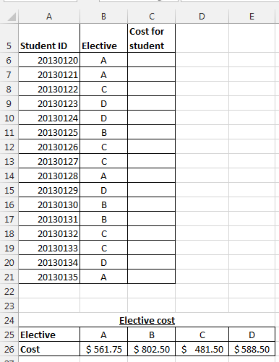

Write down an appropriate function in cell **C6** to search for the **Cost** in the **Elective cost** table for student with **Student ID**: 20130120.

……………………………………………………………………………………………………………………………………………………

1. The spreadsheet below shows the same data as question 1 except that the cost of each elective is presented differently.

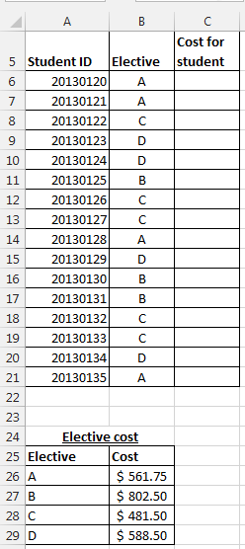

Write down an appropriate function in cell **C6** to search for the **Cost** in the **Elective cost** table for student with **Student ID**: 20130120.

………………………………………………………………………………………………………………………………………………………

1. You are required find the subsidy and allowance granted to a group of students based on their family income.

Open the file **Q3STUDENT**. You will see the following data.

Save the file as **Q3SUBSIDY**_<your name>_<index number>

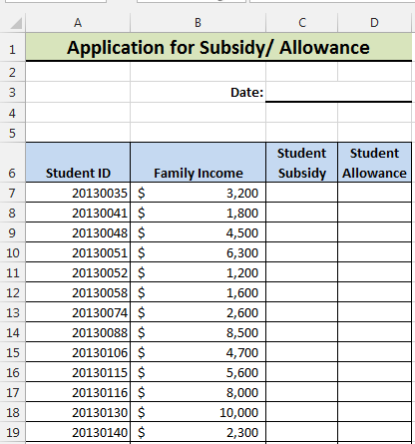

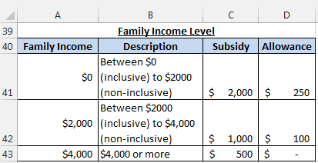

1. In cell **D3**, enter a function to show today’s date.
2. Use an appropriate function to search for the **Subsidy** in the **Family Income Level** table and use it to complete the **Student Subsidy** column.
3. Use an appropriate function to search for the **Allowance** in the **Family Income Level** table and use it to complete the **Student Allowance** column.
4. Open the file **Q4STUDENT**. Save the file as **Q4SUBSIDY**_<your name>_<index number>

The file has the same data has question 3 except that the **Family Income Level** table is presented differently.

1. In cell **D3**, enter a function to show today’s date.
2. Use an appropriate function to search for the **Subsidy** in the **Family Income Level** table and use it to complete the **Student Subsidy** column.
3. Use an appropriate function to search for the **Allowance** in the **Family Income Level** table and use it to complete the **Student Allowance** column.

**Common text functions**

|  |  |  |
| --- | --- | --- |
| **Function** | **Syntax** | **Description** |
| LEN() | =LEN(text)  **Example:**  =LEN("Computing")  This would return 9. | Returns the number of characters in the text value text |
| MID() | =MID(text, start_num, num_chars)  **Example:**  =MID("Computing", 3, 4)  This would return “mput”. | Returns num_chars characters starting from position start_num of the text value text  (Note that, unlike Python, the position of the first character is 1, not 0.) |
| LEFT() | =LEFT(text, num_chars)   * num_chars is an optional argument   **Example:**  =LEFT("Computing", 5)  This would return “Compu”. | Returns the first num_chars characters of the text value text  If num_chars is left out, the function returns only the first character of text |
| RIGHT() | =RIGHT(text, num_chars)   * num_chars is an optional argument   **Example:**  =RIGHT("Computing", 5)  This would return “uting”. | Returns the last num_chars characters of the text value text  If num_chars is left out, the function returns only the last character of text |

1. Open **Q5CCA**. You will see the following data.

Save the file as **Q5CODE**_<your name>_<index number>

The first character of the **CCA Index No.** represents the **Type of CCA** that the student is allocated. For example, U0371 represents Uniformed Group, A0054 represents Performing Arts, and C0199 represents Club and Society. The second to fifth characters represent the **Code**.

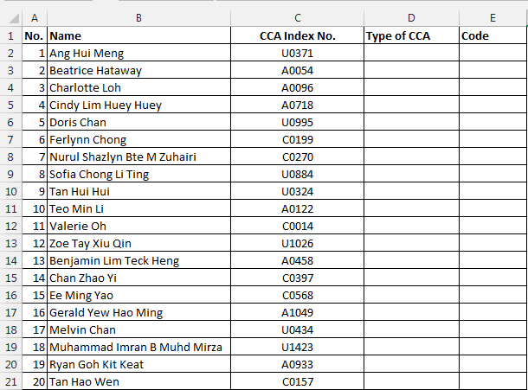

1. Use an appropriate function to display U, A or C for the type of CCA for Ang Hui Meng in cell **D2** and use it to complete the **Type of CCA** column.
2. Use an appropriate function to find the code for Ang Hui Meng in cell E2 and use it to complete **Code** column.
3. Open the file **Q6PARTICULARS**. You will see the following data.

Save the file as **Q6PARTICULARS**_<your name>_<index number>

The first character of the **ID** represent the gender of the student. The second to fifth character of the **ID** represent the year they are born in.

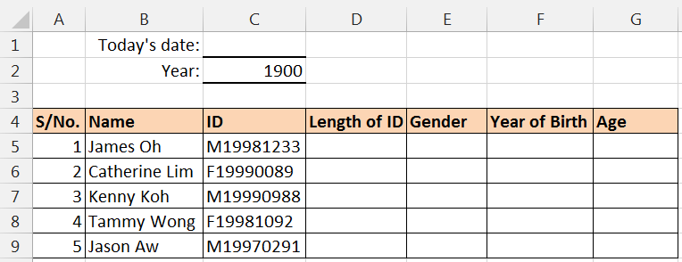

1. In cell **C1**, enter a function to show today’s date.
2. Use an appropriate function to find the number of characters of **ID** for James Oh in cell **D5** and use it to complete the **Length of ID** column.
3. Use an appropriate function to find the gender for James Oh in cell **E5** and use it to complete the **Gender** column.
4. Use an appropriate function to find the year of birth for James Oh in cell **F5** and use it to complete the **Year of Birth** column.
5. Enter a formula to find the age for James Oh in cell **G5** and use it to complete the **Age** column.
6. Assuming the text is enter in cell **A1**, write down the functions that can be used to:
7. extract "4728" from "T0134728F": ……………………………………………………………………………………
8. extract "M" from "M2013428": ………………………………………………………………………………………..
9. Circle TRUE if the statement is true or FALSE if the statement is false.
10. The LEN function will not count the spacing between the characters. TRUE / FALSE
11. The TODAY function is a volatile function. TRUE / FALSE
12. The function MID("hello", 2, 3) will return "ell". TRUE / FALSE